SoccerBot Assembly

Mount Pi to the big chassis component using

m2.5 locknut 4

m2.5 screw 4

6mm spacers 4

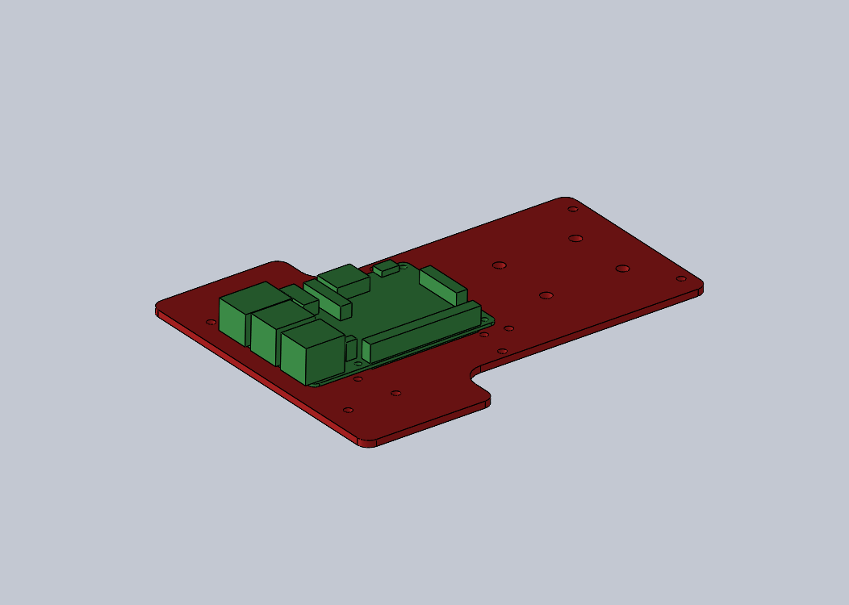

Mount the ball pusher to the big chassis component using

m3x16 2

m3 lock nuts 2

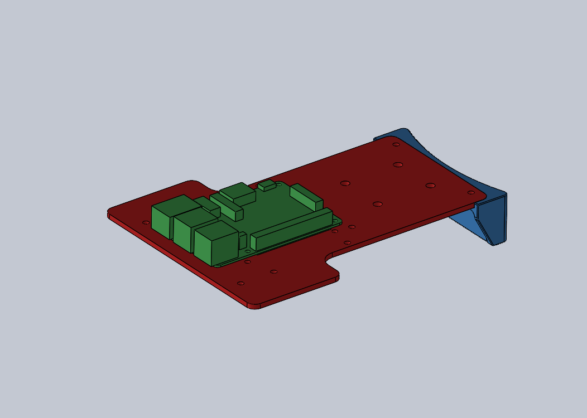

Mount Castor to big chassis component using camera/motor driver mount and little castle wall piece as well as

10-32x1/2 4

10-32 nut 4

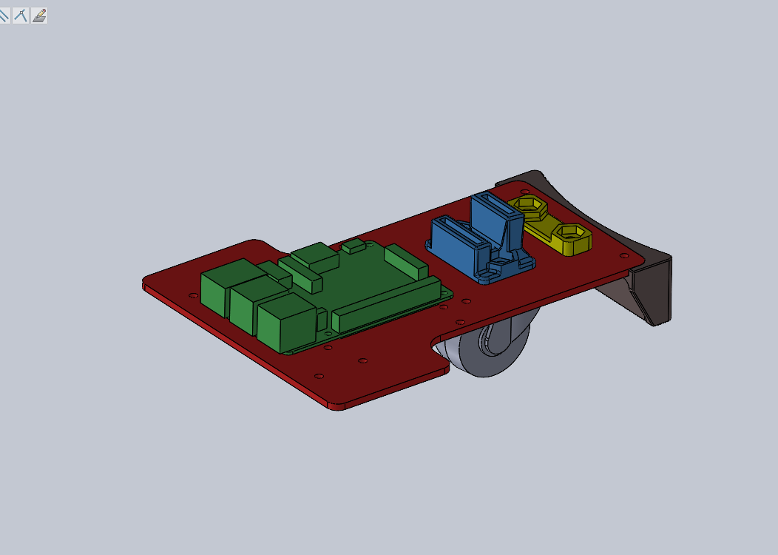

Mount wheel motors to printed chassis spacers (pay attention to orientation, the word UP should be up and the metal part of the motor should face the front of the bot) using

m3 lock nuts 4

m3x30 4

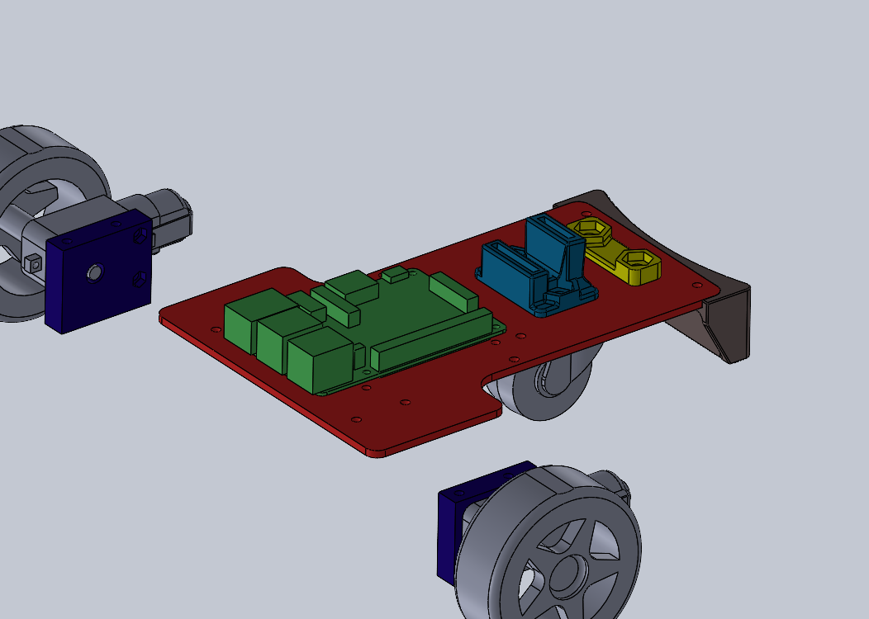

Mount corner spacers, wheel/spacer assembly to the upper chassis and lower chassis

m3x45 8

m3 lock nuts 8

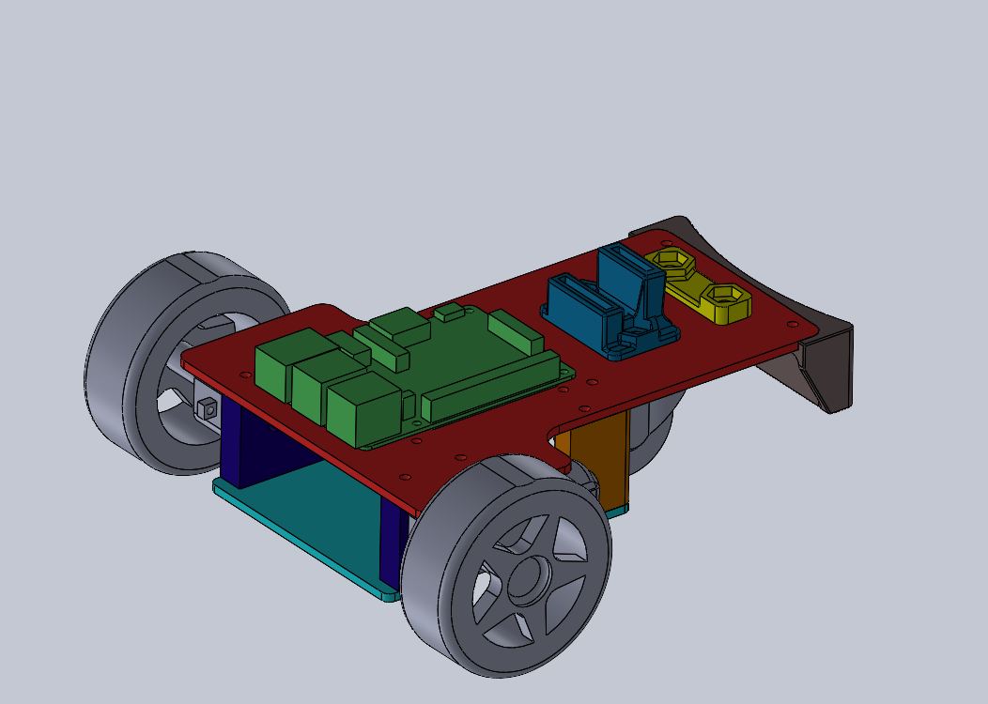

Mount the camera to the camera mast (use diagonal holes) using

m2 screw 2

m2 nut 2

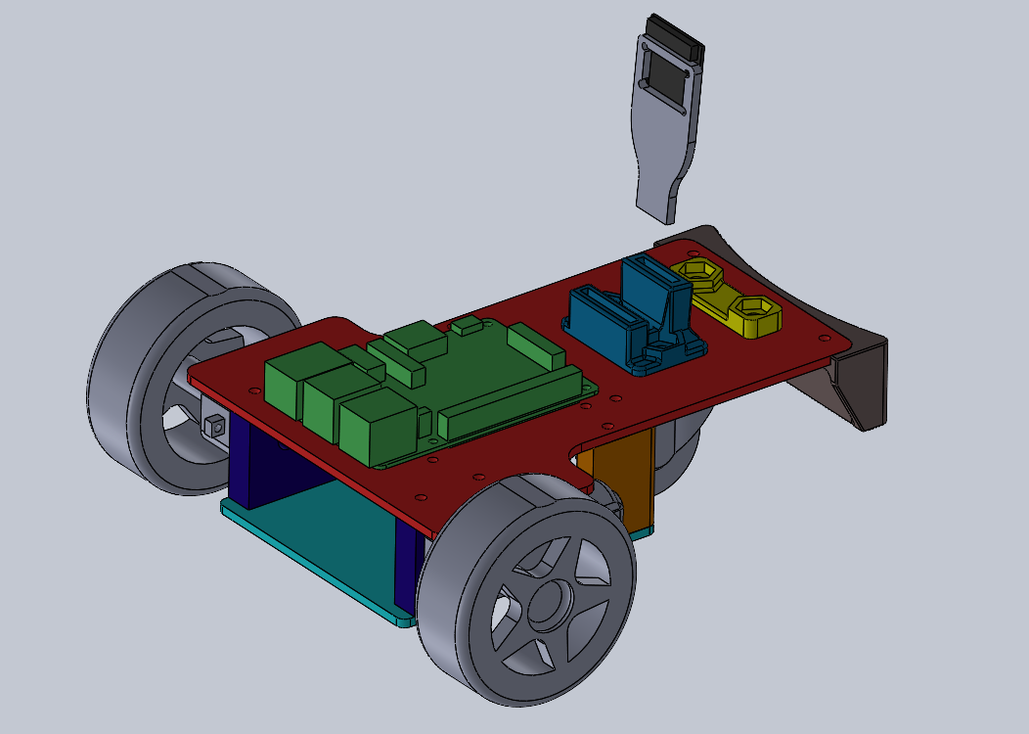

Mount the motor driver to the motor mast (usi diagonal holes) using

m2 screw 2

m2 nut 2

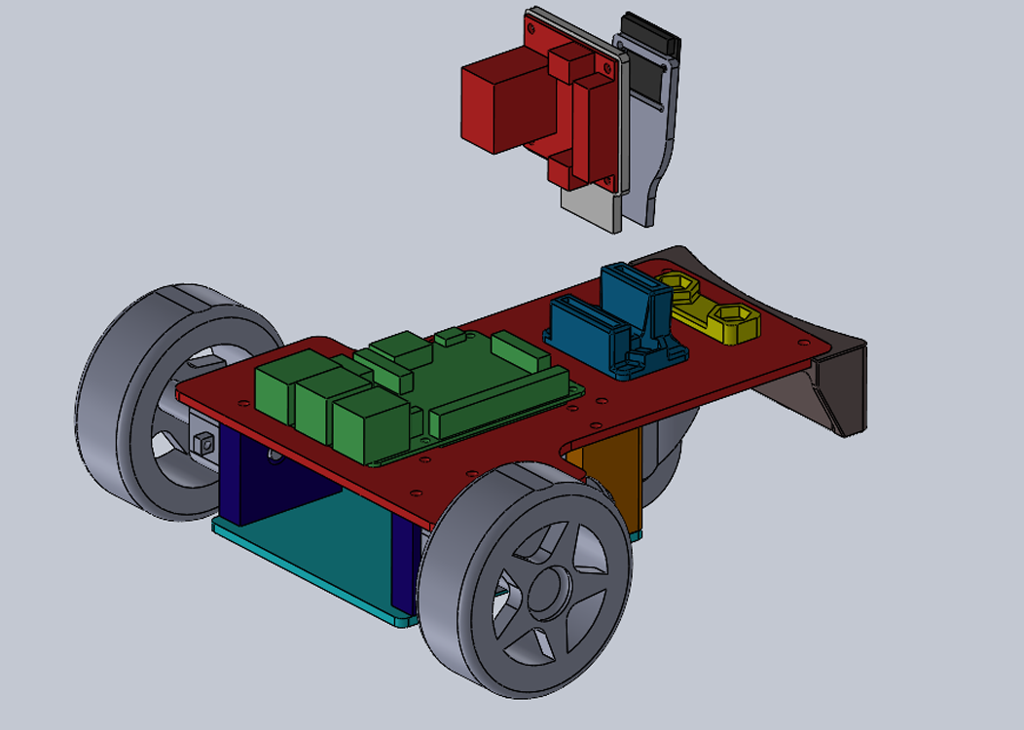

Install the camera mast and motor mast into the appropriate slots

